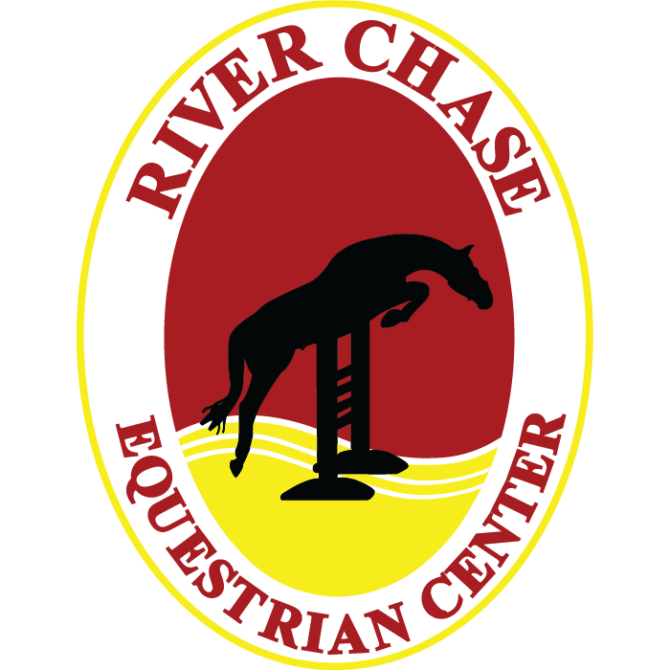
P.O. Box 18 703.777.1899
Aldie, VA 20105 www.riverchasefarm.com

PH 703.777.1899
FAX 703.991.2357
www.riverchasefarm.com

RIDER’S INFORMATION
Please Print Clearly

Rider’s Name______________________________________________________________________________
If Minor, Parent or Guardian’s Name_________________________________________________________
Address_________________________________________City________________State_____Zip_________
Email________________________________________Phone Number_______________________________
Form of Payment_________________Amount_________How did you hear about us?_________________

GENERAL USE RELEASE

WITNESS THIS RELEASE dated this ______ day of _____________, 20__, by and between
New River Chase Equestrian Center LLC , hereinafter referred to as Management, and ______________________, hereinafter referred to as User, and, if User is a minor, User's parent or guardian, ____________________________________. For consideration received, and in return for the use, today and on all future dates of the property, facilities and services of Management, Management's instructors, employees, drivers and agents; User, User's heirs, assigns, and representatives, hereby agree as follows:

1. Inherent Risks and Assumption of Risk. The undersigned acknowledges there are inherent risks associated with equine activities such as described below, and hereby expressly assumes all risks associated with participating in such activities. The inherent risks include, but are not limited to the propensity of equines to behave in ways such as, running, bucking, biting, kicking, shying, stumbling, rearing, falling or stepping on, that may result in an injury, harm or death to persons on or around them; the unpredictability of equines reaction to such things as sounds, sudden movement and unfamiliar objects, persons or other animals; certain hazards such as surface and subsurface conditions; collisions with other animals; the limited availability of emergency medical care; and the potential of a participant to act in a negligent manner that may contribute to injury to the participant or others, such as failing to maintain control over the animal or not acting within such participants ability.

User acknowledges that horses, by their very nature are unpredictable and subject to animal whim. User assumes all risks in connection therewith, and expressly waives any claims for any injury or loss arising therefrom. User agrees to abide by and follow Manager's rules and regulations which shall be posted and/or available from time to time. User further acknowledges that the behavior of any animal is contingent to some extent upon the ability of User. User assumes all risks therefore and warrants a full and fair disclosure of Rider's abilities has been made to Manager.

User expressly releases Management from any and all claims for personal injury or property damage, even if caused by negligence (if allowed by the laws of this State) by Management or its representatives, agents or employees.

Warning

Under Virginia Law, an equine activity sponsor or an equine professional shall not be liable for an injury to or death of a participant engaged in an equine activity resulting from the inherent risks of equine activities pursuant to Va. Code Ann. §3.1-796.132.

2. User agrees to assume any and all risks involved in or arising out of User's use of any equipment or livestock pertaining to the rental of horses or taking of riding lessons, the use of any arena on the premises of Management and for purposes of taking riding lessons either on the premises or lessons given off the premises by Management personnel.

3. USER (OR USERS PARENT OR GUARDIAN IF USER IS A MINOR) AGREES TO HOLD HARMLESS, INDEMNIFY AND DEFEND MANAGEMENT AGAINST ANY AND ALL CLAIMS, DEMANDS, CAUSES OF ACTION, DAMAGES, JUDGMENTS, ORDERS, COSTS OR EXPENSES, INCLUDING ATTORNEY'S FEES, WHICH MAY IN ANY WAY ARISE FROM OR BE IN ANY WAY CONNECTED WITH USER'S USE OF OR PRESENCE UPON THE PROPERTY OF MANAGEMENT AND THE FACILITIES LOCATED THEREON. In the event User is a minor, the parent or guardian shall further indemnify, defend and hold Management harmless from any such claims by said minor child.

4. In the event User is using User's own horse, or a horse(s) not owned by Management, User warrants said horse(s) shall be free from infection, contagious or transmittable diseases. Management reserves the right to refuse access or use of any horse upon the premises that does not appear to Management to be in good health, or is deemed dangerous or undesirable.

5. Any action brought under this agreement shall be brought within one (1) year of the incident or accident giving rise to said claim. User agrees that damages shall be limited to $250 for property damage, actual expenses incurred, and a maximum of $10,000 for non-consequential damages such as pain and suffering.

6. User agrees to waive the protection of any applicable statutes in this jurisdiction whose purpose, substance and/or effect is to provide that a general release shall not extend to claims, material or otherwise, which the person giving the release does not know or suspect to exist at the time of executing said release.

Parent or Guardian if User is A Minor |  | Rider
____________________________________________________
Manager/Instructor for New River Chase Equestrian Center LLC

